**Practical No. 2**

**2 Aim: Exploring and understanding TinyOS computational concept: Events,Commands and task.**

–**nesC model**

–**nesC Components**

**TinyOS Lab Exercise in Ad Hoc and Sensor Networks**

* **Sensor network programming in a nutshell**

– Read ‘Getting started with TinyOS’ (at home)

– Solve two Lab-style exercises on real hardware

– Teams of two to three students are ideal

– One lab working place is available in ETL F29

– Reservation system on the course website

– Expected time needed for all tasks: 3-4 hours

* **Shockfish TinyNode**

– Slow CPU

– 8 MHz Texas Instruments MSP430 microcontroller

– Little memory

– 10 KByte RAM, 48 KByte ROM, 512 Kbyte external flash

– Short-range radio

– 868 MHz Xemics XE1205 ultra-low power wireless transceiver

– Light sensor, temperature and humidity sensors

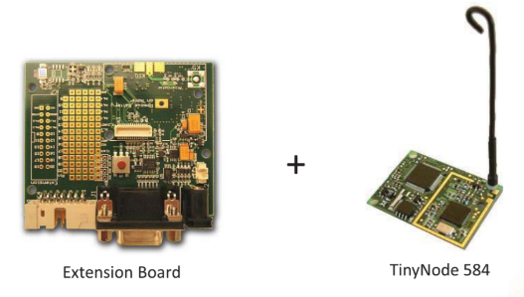

* **Exchange of a sensor data**

– Two sensor nodes are used for this task

– One node periodically samples its light sensor and broadcasts the sensor reading over its radio

– The other node listens for radio messages and signals if it is getting brighter or darker

– Brighter → The green LED of the receiver is set

– Darker → The red LED of the receiver is set

– No significant change → The yellow LED is set

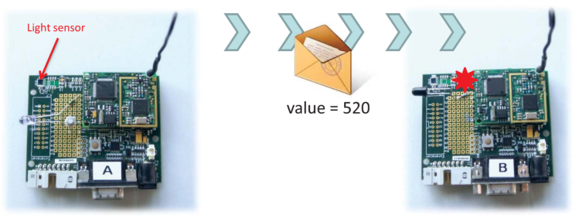

**Optical Communication using Morse Codes**

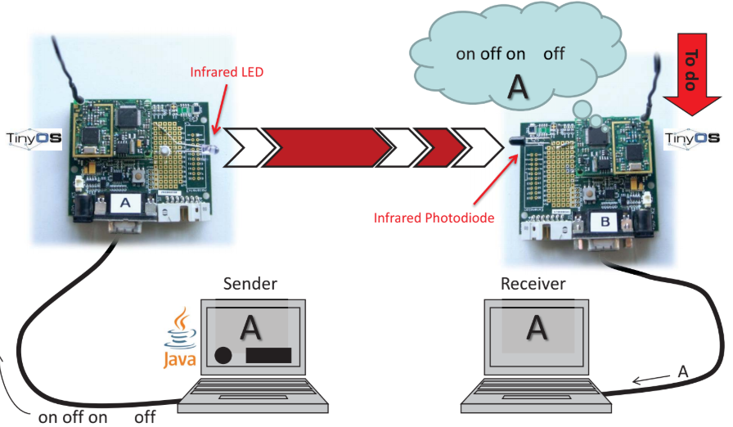

**TinyOS**

• TinyOS is an operating system for sensor nodes

– Open source project with a strong academic background

– Hardware drivers, libraries, tools, compiler

• TinyOS applications are written in nesC

– C dialect with extra features

– nesC compiler converts your application into plain C code



**Why using a new Operating System?**

• Measure real-world phenomena

–Event-driven architecture

• Resource Contraints

–Hurry up and sleep!

• Adapt to changing technologies

–Modularity & re-use

• Applications spread over many small nodes

–Communication is fundamental

• Inaccessible location, critical operation

–Robustness

**NesC/TinyOS Programming Model**

• Programs are built out of components

• Two types of components:

–Modules: Implement program logic

–Configurations: Wire components together

• Components use and provide interfaces

• Components are wired together by connecting interface users with interface providers

**Programming Model**

• Interfaces contain definitions of

–Commands

– Events

• Components implement the event handlers they use and the commands they provide

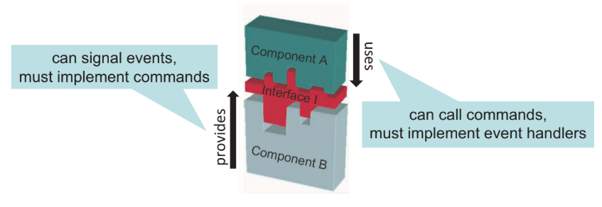

**Concurrency Model**

• Coarse-grained concurrency only

–Implemented via tasks



• Tasks are executed sequentially by the TinyOS scheduler

–no threads

–Atomic with respect to other tasks (single threaded)

–Longer background processing jobs

• Events (interrupts)

–Time critical

–Preempt tasks

–Short duration (hand off computation to tasks if necessary)

**Memory Model**

• Static memory allocation

–No heap (malloc)

–No function pointers

• Global variables

–One namespace per component

• Local variables

–Declared within a function

–Saved on the stack

• Conserve memory

• Use pointers, don‘t copy buffers

**nesC – Hello World**

module BlinkC {

uses interface Timer<TMilli>

as BlinkTimer;

uses interface Leds;

uses interface Boot;

}

implementation{

event void Boot.booted() {

call BlinkTimer.startPeriodic(1000);

}

event void BlinkTimer.fired() {

call Leds.led0Toggle();

}

}

• Blink the red LED every second

• On boot start a 1 second timer

• On timer fire (countdown at 0)

–Toggle the state of the red LED

–Reset the timer to 1 second

**nesC – Hello World**

interface Timer<precision_tag> {

event void fired();

command void startPeriodic(...);

command void startOneShot(...);

command void stop();

…

}

configuration BlinkAppC{

}

implementation {

components MainC, BlinkC,

LedsC;

components new TimerMilliC()

as Timer0;

BlinkC.Boot -> MainC.Boot;

BlinkC.BlinkTimer -> Timer0;

BlinkC.Leds -> LedsC.Leds;

}

module BlinkC {

uses interface Timer<TMilli>

as BlinkTimer;

uses interface Leds;

uses interface Boot;

}

implementation {

event void Boot.booted() {

call BlinkTimer.startPeriodic(1000);

}

event void BlinkTimer.fired() {

call Leds.led0Toggle();

}

}